**Download Kafka – Example**

[**https://kafka.apache.org/quickstart**](https://kafka.apache.org/quickstart)

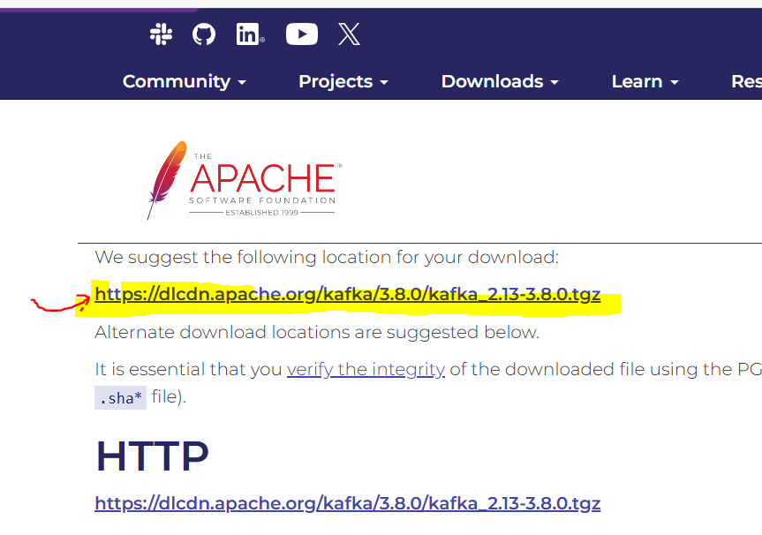

Save in Downloads folder

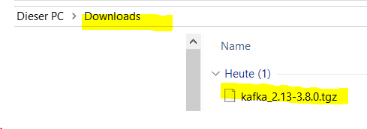

**Command:**

C:\Users\Family\Downloads>dir

Datenträger in Laufwerk C: ist Windows

Volumeseriennummer: 0E81-013A

Verzeichnis von C:\Users\Family\Downloads

01.08.2024 22:00 120’735’482 kafka_2.13-3.8.0.tgz

C:\Users\Family\Downloads>tar -xzf kafka_2.13-3.8.0.tgz

C:\Users\Family\Downloads>

23.07.2024 10:09 <DIR> kafka_2.13-3.8.0

01.08.2024 22:00 120’735’482 kafka_2.13-3.8.0.tgz

C:\Users\Family\Downloads>

**Suggestion** 🡪 <https://www.youtube.com/watch?v=SqVfCyfCJqw>

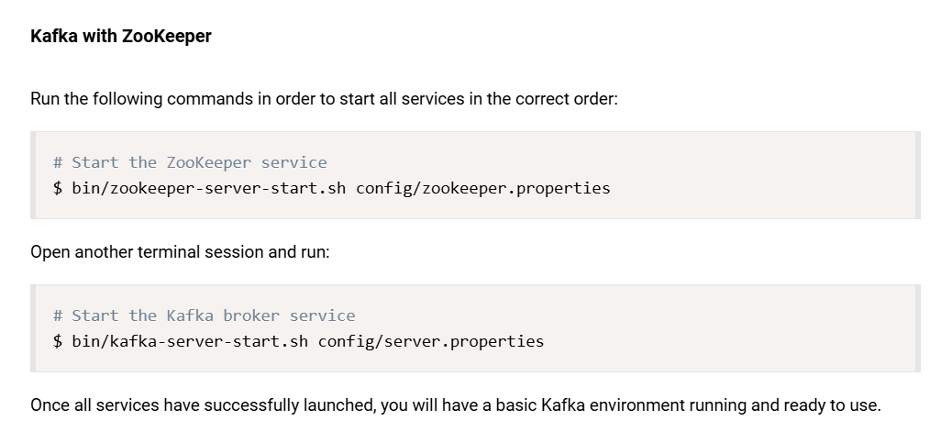

**# Start the ZooKeeper service**

C:\Users\Family\Downloads\kafka_2.13-3.8.0>bin\zookeeper-server-start.sh config\zookeeper.properties

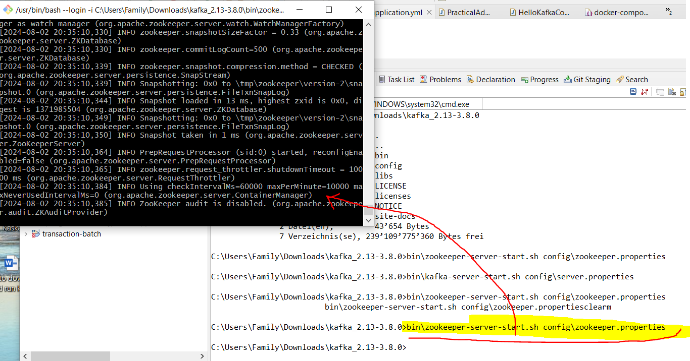

**# Start the Kafka broker service**

C:\Users\Family\Downloads\kafka_2.13-3.8.0>bin\kafka-server-start.sh config/server.properties

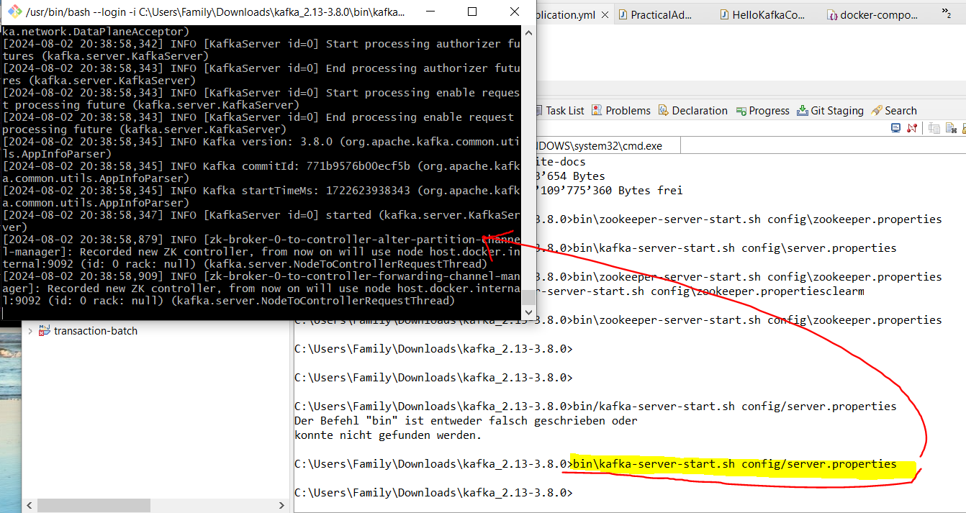

Refer to: <https://thepracticaldeveloper.com/spring-boot-kafka-config/>

To start up Kafka and Zookeeper containers, just run docker-compose up from the folder where this file lives.

Install Docker Desktop on Windows -->  
<https://docs.docker.com/desktop/install/windows-install/>

START DOCKE IN DESKTOP

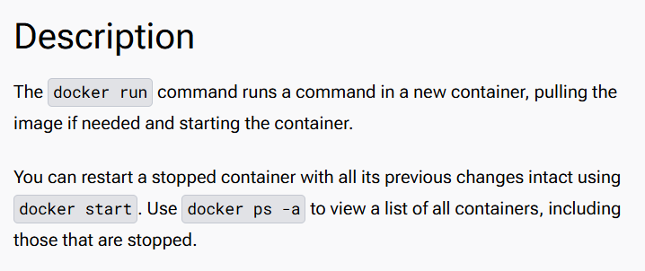

C:\Users\Family\git\kafka-spring-boot-example>docker --version

Docker version 25.0.2, build 29cf629

C:\Users\Family\git\kafka-spring-boot-example>docker-compose up

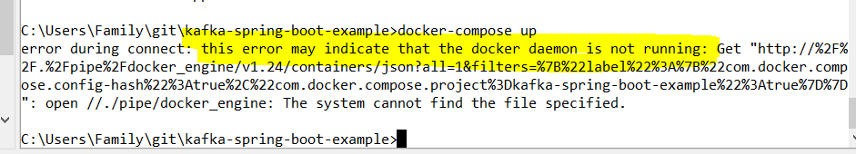

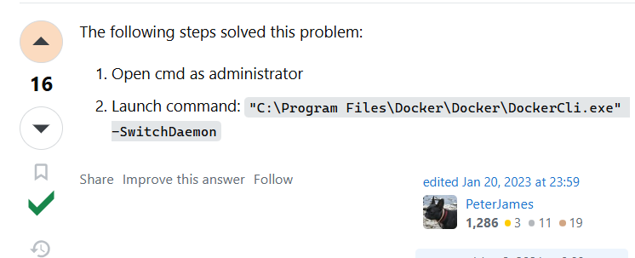

"C:\Program Files\Docker\Docker\DockerCli.exe" -SwitchDaemon

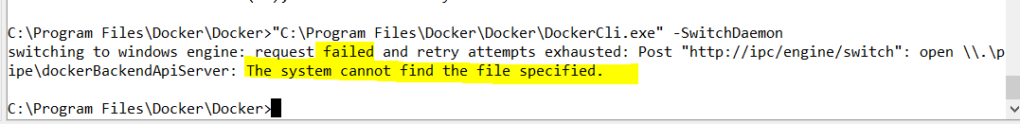

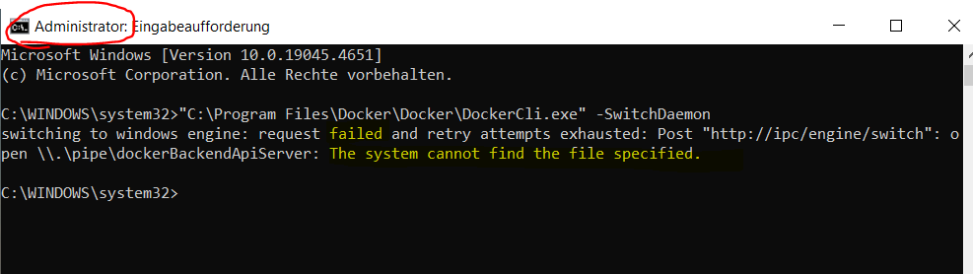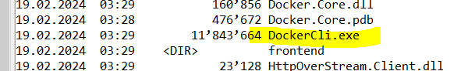

Go to document: “2. how to run docker engine and docker-compose up on window 10.docx” to run the docker engine and then re-run:

C:\Users\Family\git\kafka-spring-boot-example>docker-compose up